Feedback Code | Feedback Code
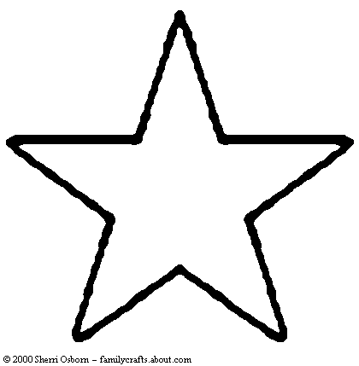= Wow, you’ve got it!  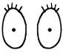=Look what I learned!  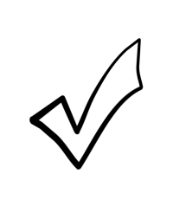= Check over your work!  SP= Spelling mistake  LF= incorrect letter formation  NF=incorrect number  formation  =punctuation  __  __ = Capital letter  __  =Give more ideas! | = Wow, you’ve got it!  =Look what I learned!  = Check over your work!  SP= Spelling mistake  LF= incorrect letter formation  NF=incorrect number  formation  =punctuation  __  __ = Capital letter  __  =Give more ideas!

